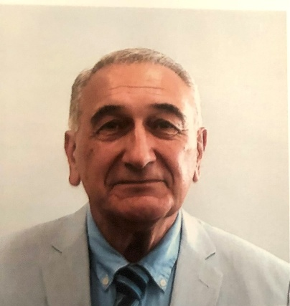

The author was educated at Michigan State University, East Lansing, Michigan. He received his Ph.D. in Theoretical Nuclear Physics in 1983. His major interest was Pion Absorption in Nuclei. After a short post-doctoral appointment at the National Superconducting Laboratory, he joined the Physics Department of The Pennsylvania State University at York. For years, he collaborated with the staff scientists at the Los Alamos Meson Physics Facility (LAMPF) in Los Alamos, New Mexico, and published papers on Pion-Induced Nuclear Reactions. Since the inception of Mathematica in 1985, he developed a keen interest in applying the software to teaching and research. To date, he has published and presented more than 100 articles on applications of Mathematica at more than forty international conferences. He organized international special sessions for Mathematica practitioners. He is the recipient of the first Teaching Award at York and the Star Award within the University College of Penn State University. The latter is merited for introducing Mathematica in the classroom. He is a recipient of the Faculty Scholarship and Creative Accomplishment at York and the Wolfram Scholar Visitor’s Award. Currently, he is a professor of theoretical physics at PSU-York and holds the endowed John T. and Paige S. Smith Professor of Science Chair.

1983 Ph.D., Michigan State University, Theoretical Nuclear Physics
1977 M.Sc., Michigan State University, Physics
1973 M.Sc., Pars College, Theoretical Physics
1971 B.Sc., Pars College, Minor in Mathematics

